**Output Screenshots**

**Visual studio 2019(O/P):**

**Postman(O/P):**

**HomePage(O/P):**

**Edit(O/P):**

**Edit view:**

**Updating values by using Edit Option:**

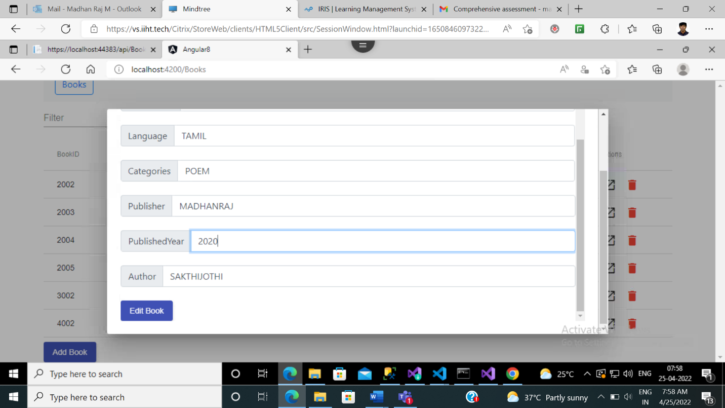

**Edited views:**

**Delete(O/P):**

**Delete method**

**Deleted successfully**

**Add(O/P):**

**Add method**

**Add View**

**Adding Datas**

**Added Successfully**

**GIT(O/P):**

